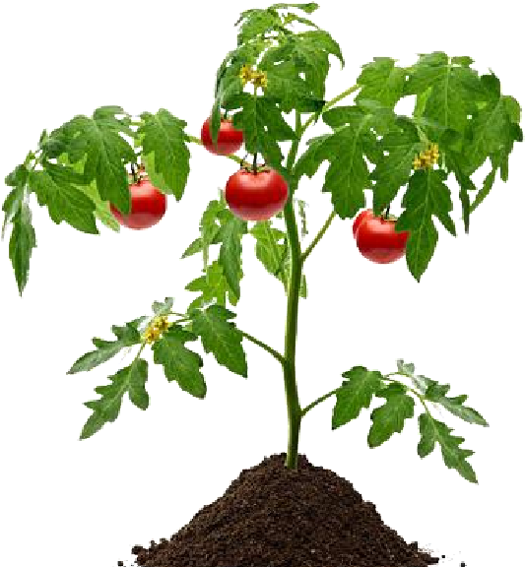
A Precision Agriculture Technique for Optimum Irrigation in Tomato Plant

Pritam

Gurung

(
030)
PAS075BGE

Roshan
Kafle
PAS075BGE
(
033
)

Samir
Pahari (PAS075BGE035)

Sujan

Adhikari
(
043
PAS075BGE
)

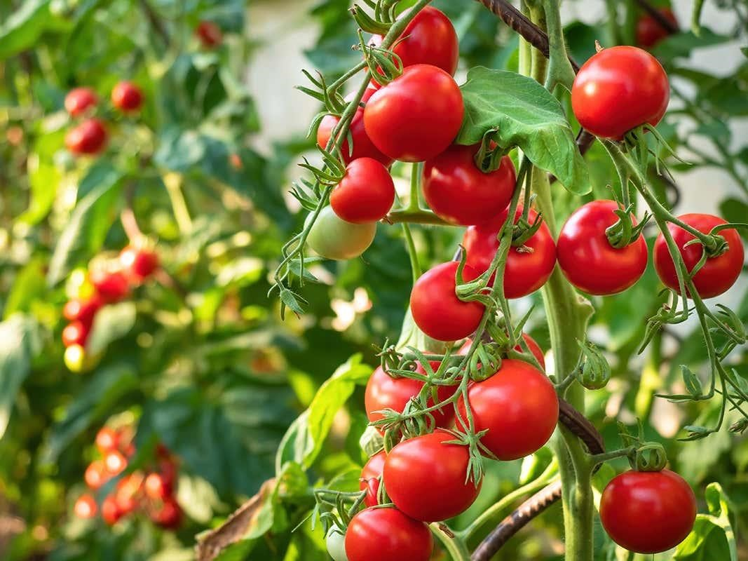
To identify the suitable amount of
Water or
moisture for high
productivity of tomato.

OBJECTIVES

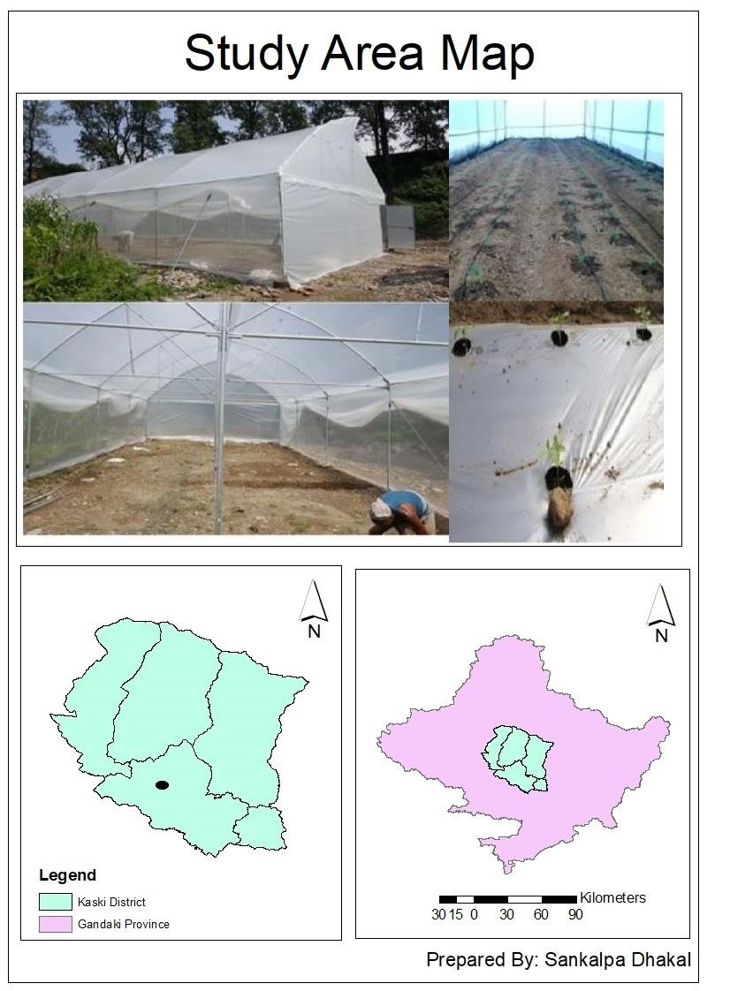
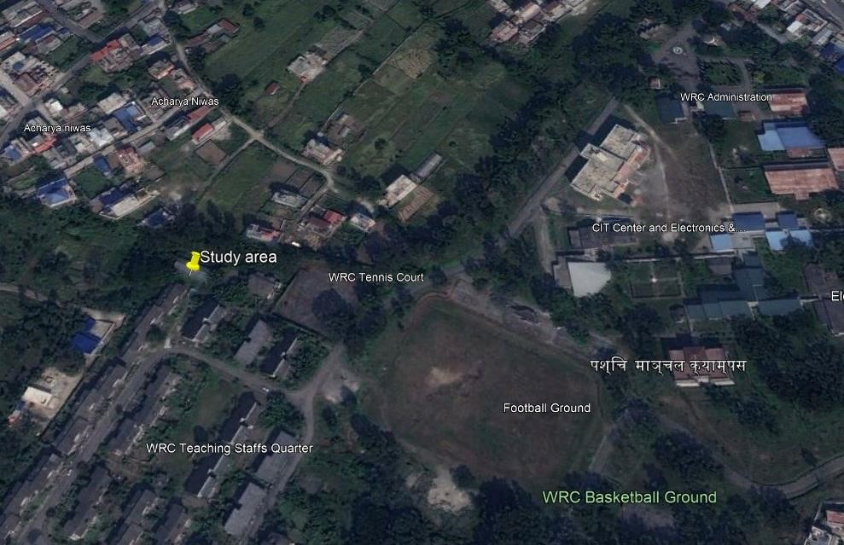
STUDY AREA

METHODOLOGY
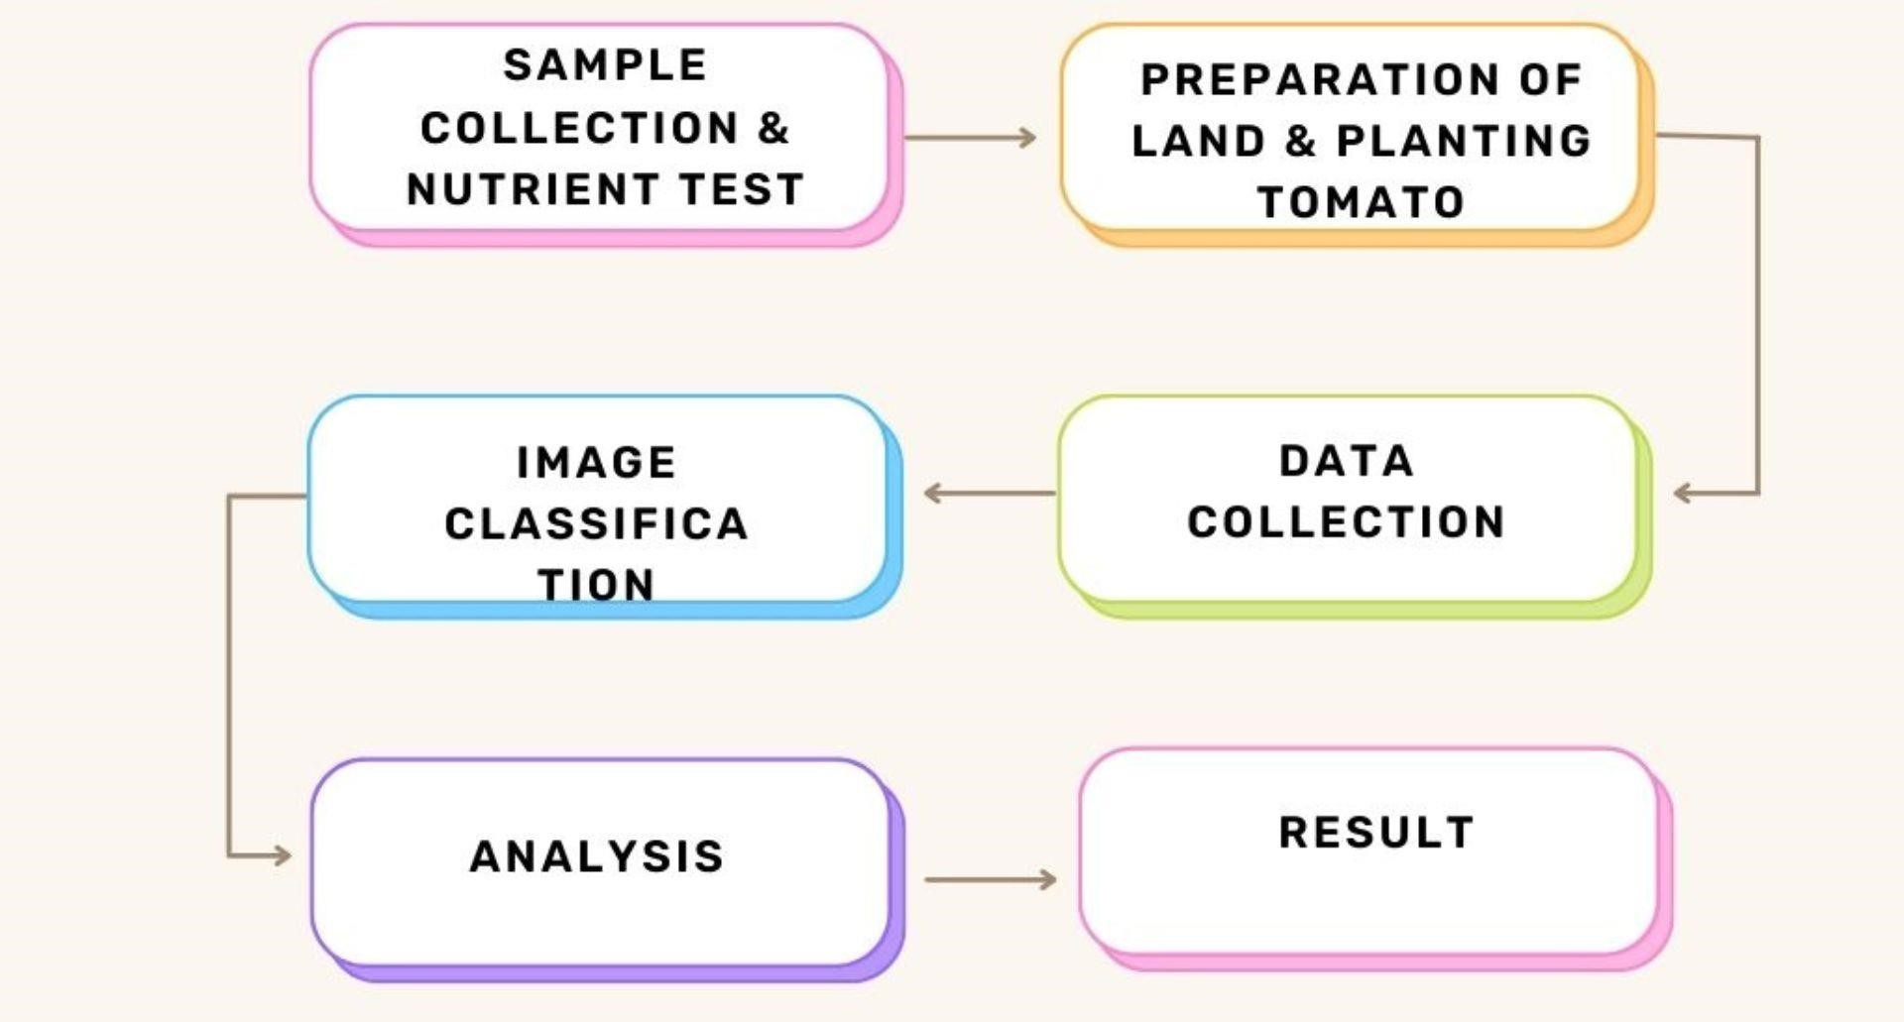

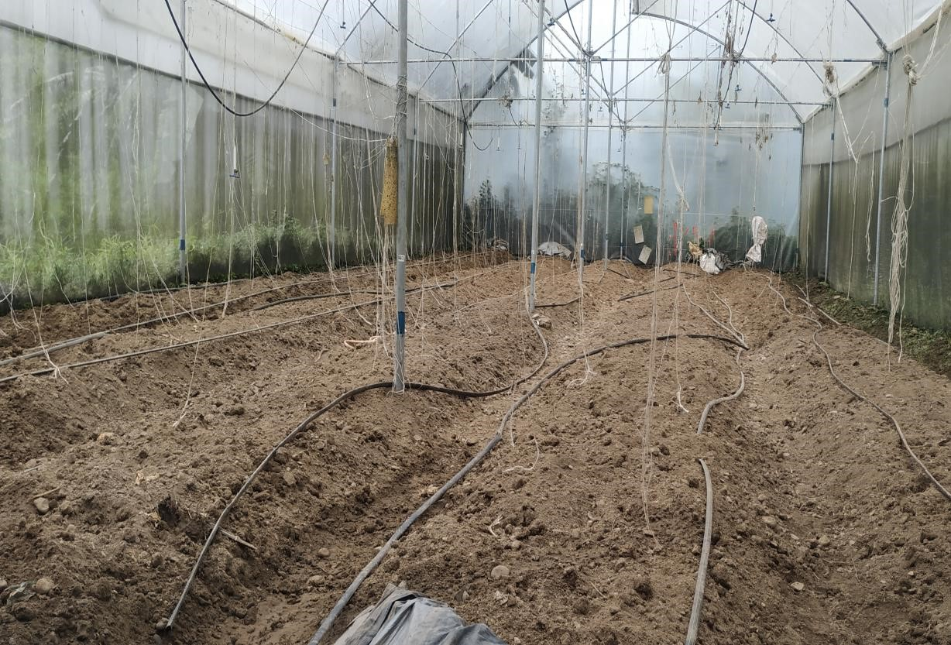
Soil Sample Collection
- Using handheld auger
- From top soil
- From five different parts
on the field

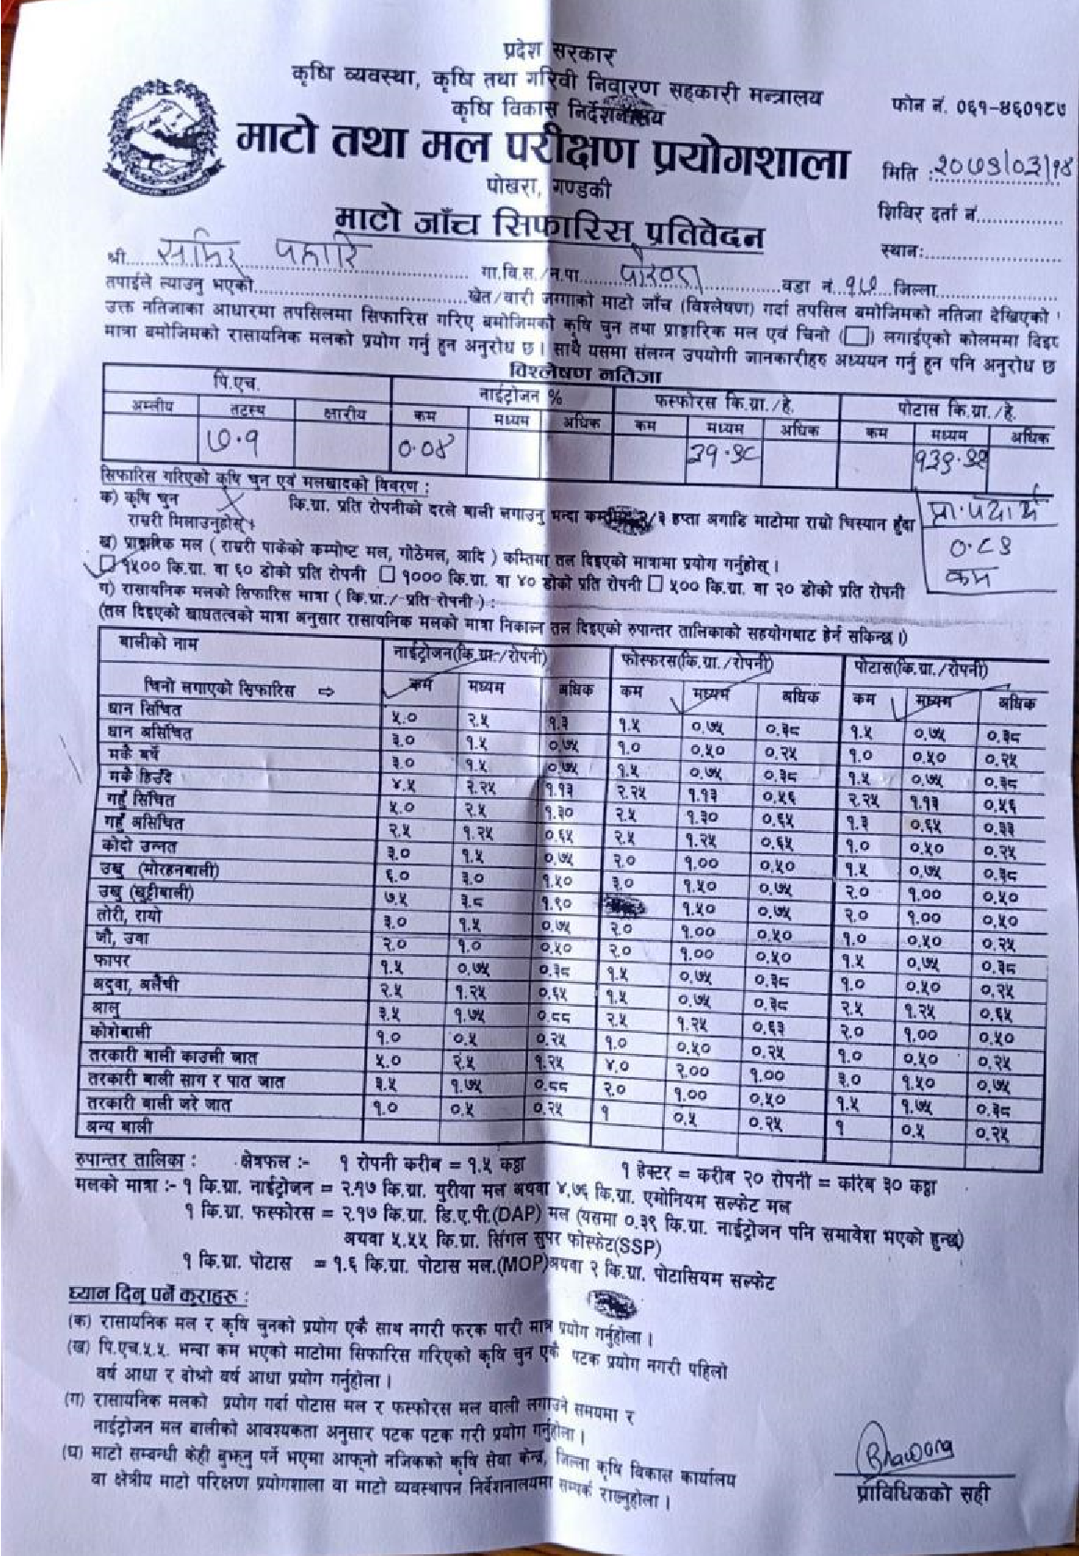
Soil Nutrition test
pH value  Normal = 7.1 | Nitrogen (%)  Less= 0.04 | Phosphorus (kg/hec)  Medium = 31.98 | Potassium (kg/hec)  Medium = 139.92
Table : Nutrient status of soil sample.

Preparation of land
- 150kg of FYM was added along with 9.518kg urea,
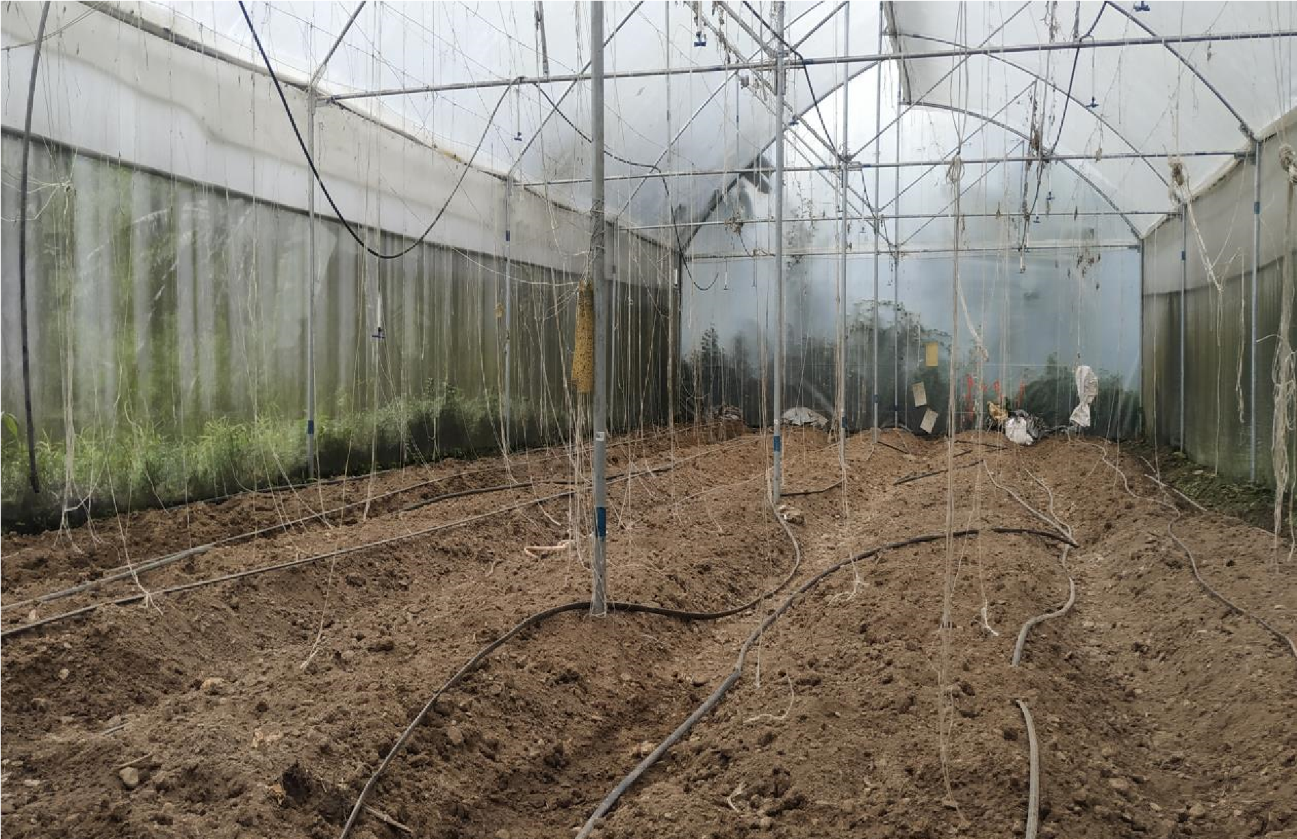
2.68kg DAP and 3.17kg MOP.
- Total 5 Plots each contains 3 subplots. (5*3 = 15 subplots)

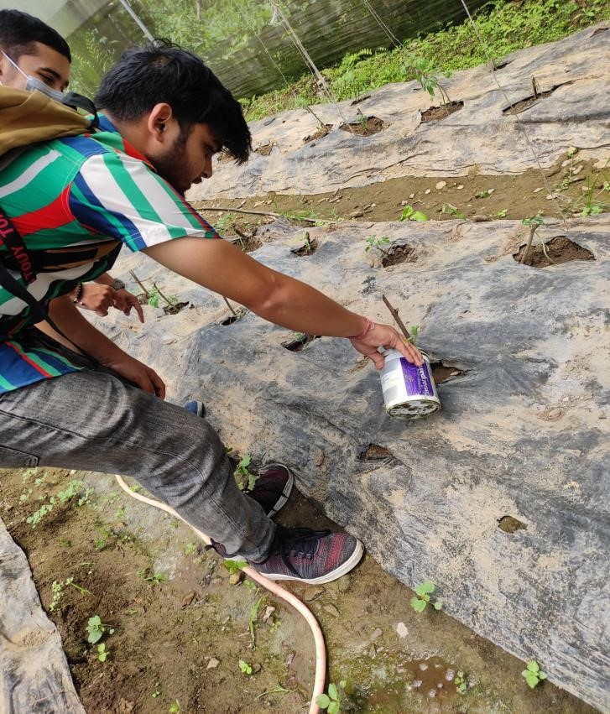
Irrigation
- Divided into different plot 25%, 50%, 75% and 100% field capacity.

Data Collection
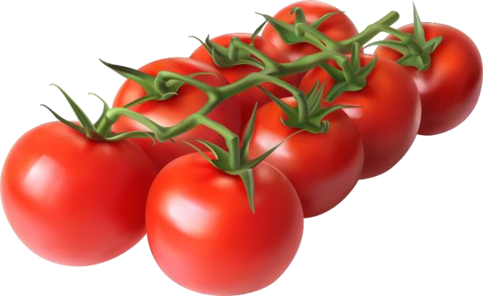
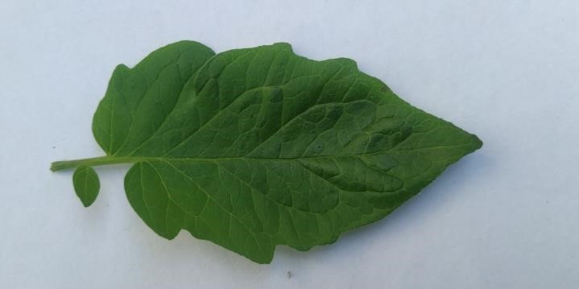
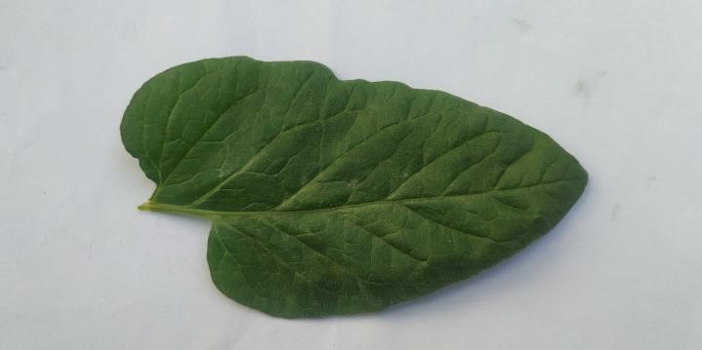
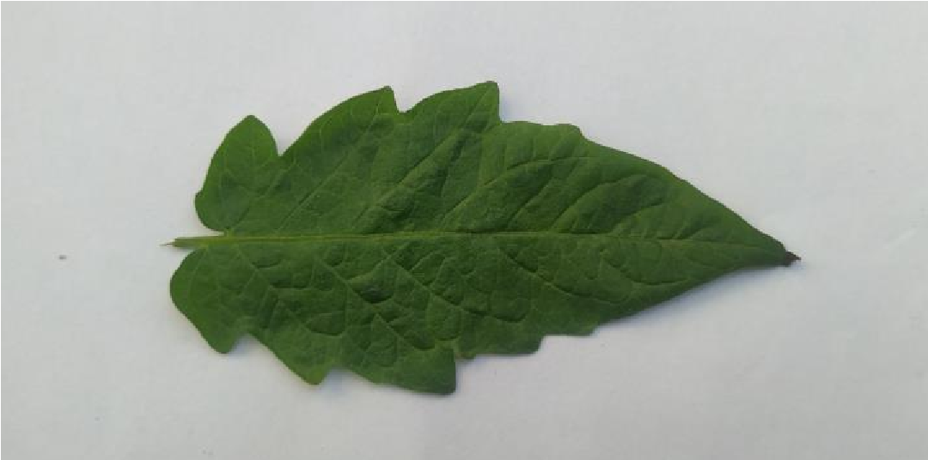
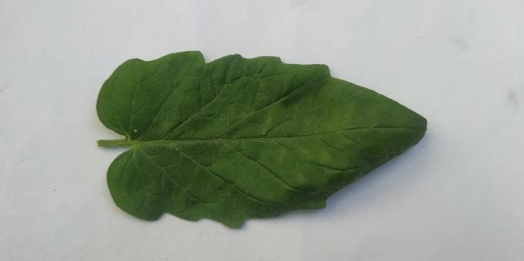
Image Capturing
Soil Moisture

Table : Moisture Data
Date | Plot A | Plot B | Plot C | Plot D | Plot E | Plot F | Plot G | Plot H | Plot I | Plot J | Plot K | Plot L | Plot M | Plot N | Plot O
4/30/2079 | 18.7 | 22.4 | 16.6 | 19.5 | 24.7 | 14.4 | 15.4 | 20.2 | 18.6 | 13.1 | 17.2 | 10.3 | 23.1 | 25.2 | 18.5
5/8/2079 | 22.3 | 23.1 | 18.5 | 22.7 | 29.3 | 15.3 | 19.7 | 24.6 | 24.3 | 22.5 | 19 | 14.9 | 13.8 | 22.4 | 18.7
5/23/2079 | 16.6 | 18.8 | 21.2 | 14.7 | 13.8 | 9.9 | 12.9 | 20.5 | 13.9 | 12.6 | 22.4 | 20.3 | 16.3 | 11.1 | 20.2
6/2/2079 | 10.5 | 16.8 | 15.7 | 13.5 | 24.5 | 10.6 | 11.9 | 20.2 | 9 | 23.1 | 23.7 | 21.5 | 12.8 | 14.4 | 22.6
6/13/2079 | 15.5 | 20.3 | 19 | 17 | 20.3 | 12.9 | 17.3 | 18.4 | 13.8 | 16.4 | 13.4 | 20.5 | 11.5 | 14.6 | 19.7
6/27/2079 | 28.1 | 23.3 | 18 | 21.5 | 21.4 | 14.6 | 24 | 14 | 16.9 | 12.4 | 13.4 | 22.4 | 7.1 | 9.2 | 22.4
7/6/2079 | 16.6 | 18.8 | 21.2 | 14.7 | 13.8 | 9.9 | 12.9 | 20.5 | 13.9 | 12.6 | 22.4 | 20.3 | 16.3 | 11.1 | 20.2
7/14/2079 | 18.7 | 16.8 | 15.7 | 13.5 | 24.5 | 10.6 | 11.9 | 20.2 | 9 | 23.1 | 23.7 | 21.5 | 12.8 | 14.4 | 22.6
7/20/2079 | 20.2 | 23.1 | 20.3 | 16.3 | 11.1 | 15.3 | 19.7 | 24.6 | 29.3 | 22.5 | 19 | 14.9 | 13.8 | 22.4 | 18.7
7/30/2079 | 19.7 | 18.8 | 21.5 | 12.8 | 14.4 | 9.9 | 12.9 | 9.9 | 12.9 | 20.5 | 22.4 | 20.3 | 16.3 | 11.1 | 20.2
8/7/2079 | 15.5 | 20.3 | 7.1 | 17 | 20.3 | 12.9 | 17.3 | 18.4 | 24.5 | 16.4 | 13.4 | 20.5 | 11.5 | 14.6 | 19.7
Date | Plot A | Plot B | Plot C | Plot D | Plot E | Plot F | Plot G | Plot H | Plot I | Plot J | Plot K | Plot L
6/29/2079 | 0.712 | 0.712 | 0.396 | 1.512 | 1.418 | 0.724 | 0.642 | 0.66 | 0.452 | 0.404 | 0.566 | 0.604
7/1/2079 | 0.76 | 1.478 | 1.29 | 2.654 | 2.654 | 1.48 | 0.438 | 1.316 | 1.884 | 0.896 | 2.502 | 0.752
7/5/2079 | 1.98 | 0.614 | 1.338 | 1.748 | 1.888 | 1.178 | 1.264 | 0.884 | 1.946 | 1.298 | 1.528 | 1.164
7/11/2079 | 1.556 | 2.216 | 2.636 | 5.443 | 3.646 | 3.556 | 2.558 | 2.78 | 1.484 | 1.894 | 1.814 | 1.946
7/15/2079 | 1.214 | 2.168 | 3.864 | 1.423 | 1.448 | 1.508 | 0.432 | 1.556 | 0.45 | 1.566 | 0.574 | 1.208
8/8/2079 | 1.86 | 1.29 | 0.498 | 0.934 | 1.838 | 0.288 | 1.186 | 1.888 | 0.15 | 1.864 | 0.62 | 0.428
Sum | 8.082 | 8.478 | 10.022 | 13.714 | 12.892 | 8.734 | 6.52 | 9.084 | 6.366 | 7.922 | 7.604 | 6.102
 |  | 100% Field Capacity |  |  | 75% Field  Capacity |  |  | 50% Field Capacity |  |  | 25%  Field  Capacity

Fruit yield

DATA ARRANGEMENT
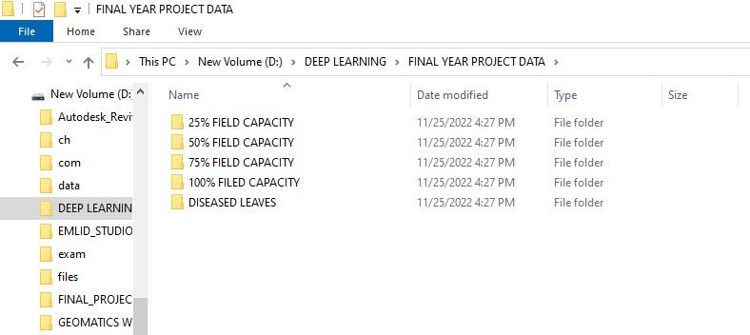
Train Test Split

Model Building

Processing

Post
-

Processing

Pre
-

Processing

Resizing and
Rescaling

Data
Augmentation

Prediction on Test
Data

Model Deployment
in Web Application

Data Splitting

Test Data

Model

Train Data

Predict

Function

Pre - Processing
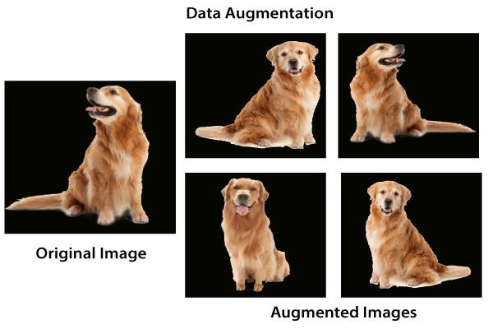
- RESIZING
- RESCALING • DATA AUGMENTATION
CNN
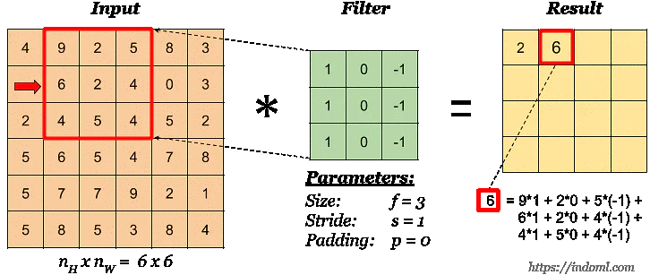
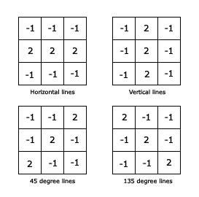
Filter

Horizontal Filter


Transfer Learning

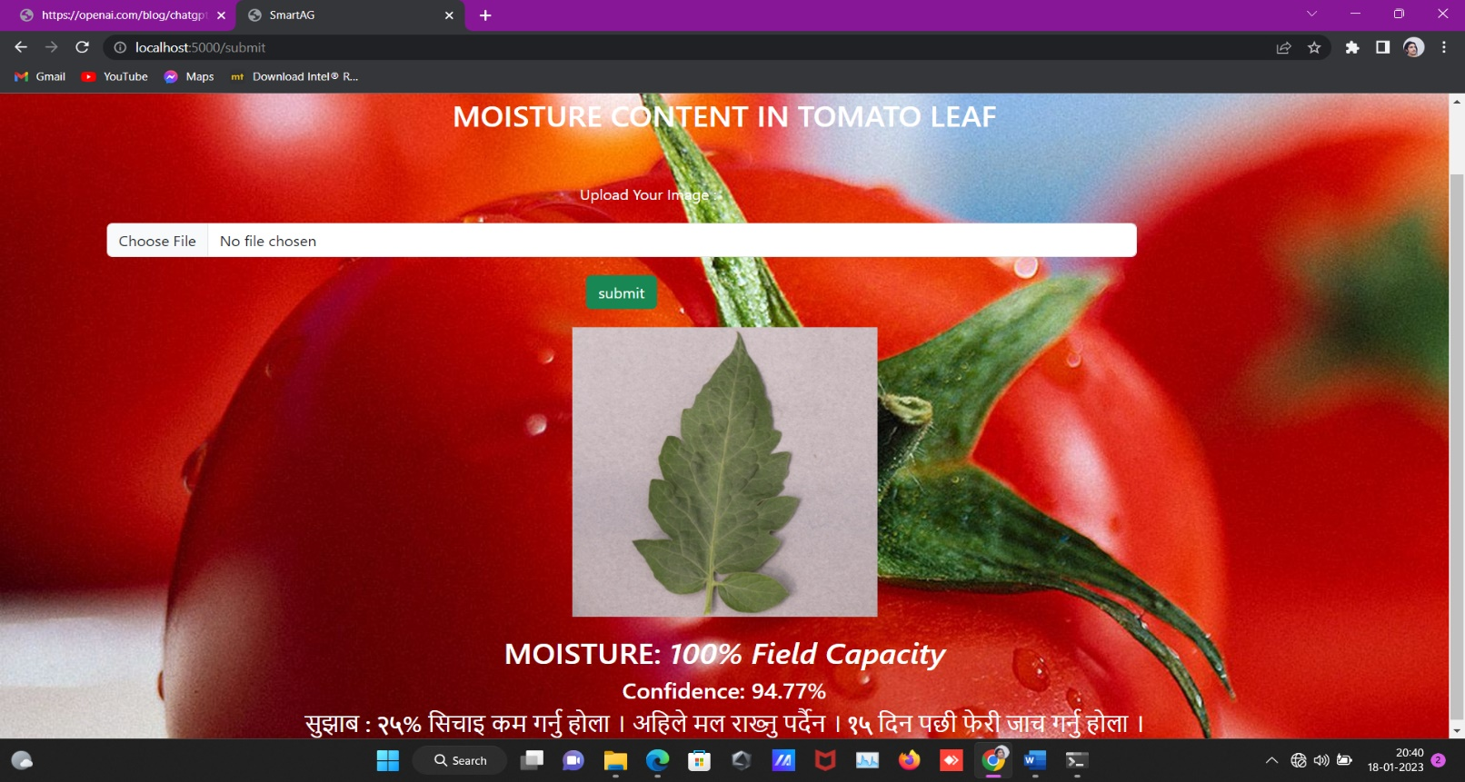
Web App

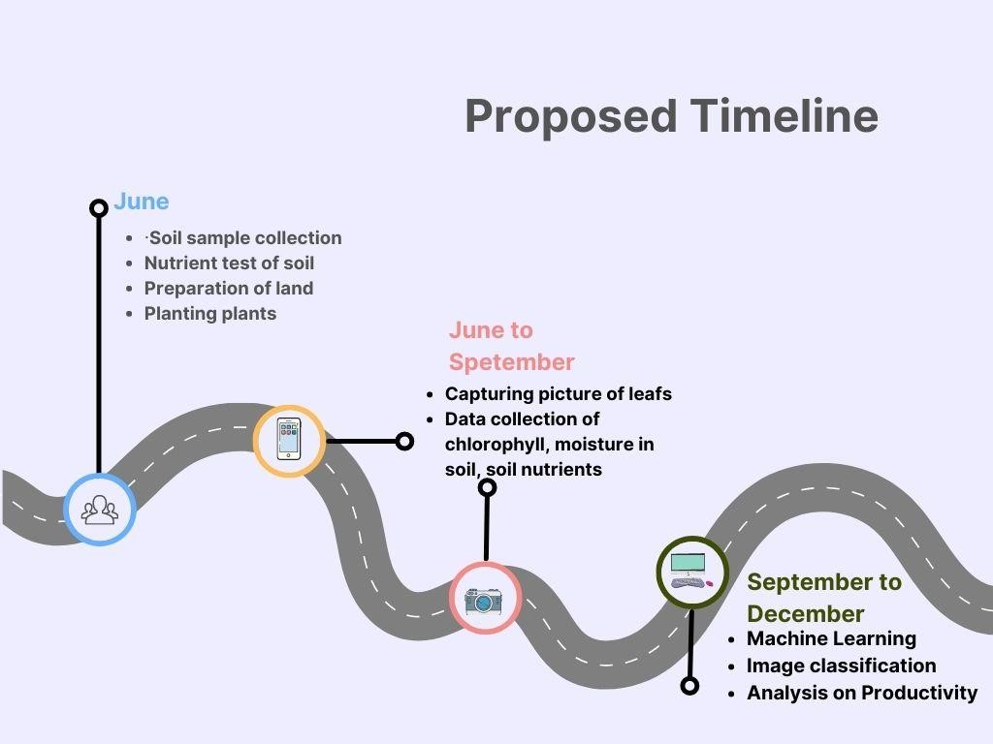
TIMELINE

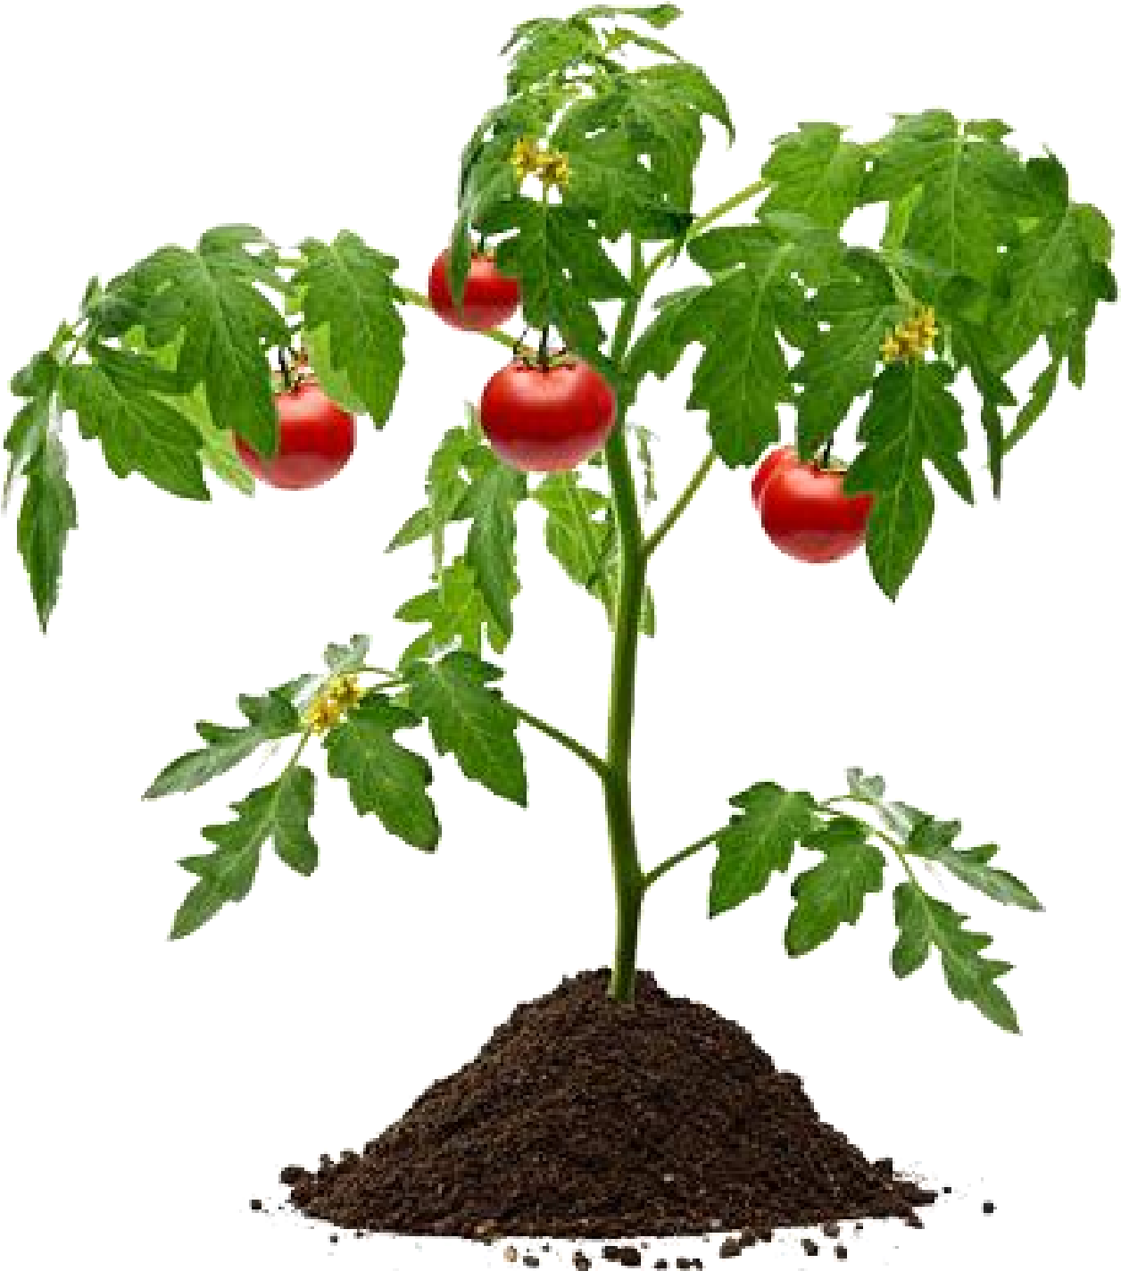
THANK YOU

